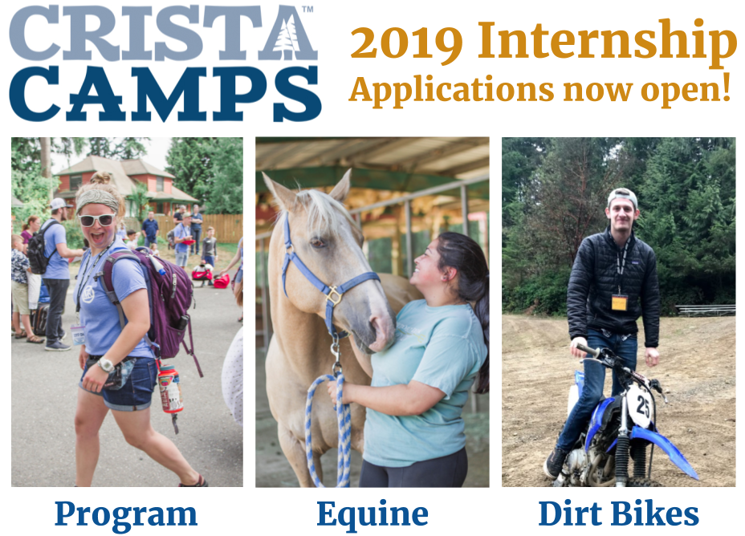

Program Track
Program interns are deeply acquainted with all aspects of the guest experience from hospitality to activities to the camp store. They are responsible hosting guest groups, executing camp programming, leading and assisting in camp turnovers, maintaining and facilitating camp activities, recruiting staff, campers, and volunteers, and completing special projects.

Equine Track
Horse interns are fully immersed in the day to day operations of the barn. They are responsible for daily chores, barn upkeep, rodeos, trail rides, riding lessons, keeping horses in shape and assisting in horse therapy. Horse interns may specialize in either horsemanship, barn management, or equine therapy. Some choose to use this year to acquire their hours for PATH and CHA certifications.

Dirt Bike/Program Track
Dirt Bike interns know all the ins and outs of trails, bike maintenance, and lessons while filling in for program needs. They are responsible for coaching both riding and mechanic fundamentals, inventory management, motorcycle maintenance, volunteer/staff management, and facilitating safety in the context of the sport of dirt bike riding.
The Program
The CRISTA Camps Internship Program exists to develop qualified ministry leaders through service-driven hospitality. This 12-month internship program is the perfect opportunity for a recent college graduate who is passionate about developing the skills and experience necessary to become a full-time camping or ministry professional. Other specializations such as business, marketing, or food service available on a case by case basis.

An Average Week
Interns work at both Island Lake and Miracle Ranch but are based out of Miracle Ranch. During the school year, interns spend one day each week in vocational and spiritual development classes, five days working within their internship track and one day off without camp or internship responsibilities.

Qualifications
- 21 years old or older (essential)
- *Associate’s degree or equivalent experience (essential)
- *Bachelor’s degree or equivalent experience (preferred)
- Personal Commitment to Jesus Christ
*One year of relevant experience may be substituted for each year of required education on a case by case basis

Stipend & Benefits
- Free room & board, laundry, and internet access
- Free vocational development classes
- Free wilderness and lake house trip
- Free ACCT Level I Ropes & Red Cross Lifeguard certifications
- $600/month stipend with a $200/month bonus during summer camp
Note: Health insurance is NOT provided by CRISTA Camps

Cohort | App Deadline | Start Date | End Date
Fall 2019 | Aug 11th, 2019 | Aug 25th, 2019 | Sept 6th, 2020
Spring 2020 | Dec 11th, 2019 | Jan 5th, 2020 | Dec 10th, 2020

Apply now at cristacamps.com/get-involved/internships

